EXPERIMENT- 10
Erode an Image using Erode Function
Aim
To write a Python code to perform image erosion using OpenCV for shrinking object boundaries and removing small noise from the image.
Input Image
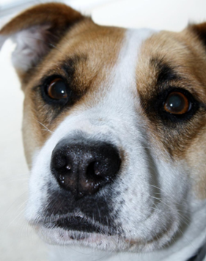
Code
import cv2
import numpy as np
from google.colab.patches import cv2_imshow
from google.colab import files
uploaded=files.upload()
image_path=list(uploaded.keys())[0]
image=cv2.imread(image_path,cv2.IMREAD_GRAYSCALE)
if image is None:
print("Error: Image not found")
else:
kernel=np.ones((5,5),np.uint8)
eroded_image=cv2.erode(image,kernel,iterations=1)
print("Original Image")
cv2_imshow(image)
print("Eroded Image")
cv2_imshow(eroded_image)
Output Image
Eroded Image
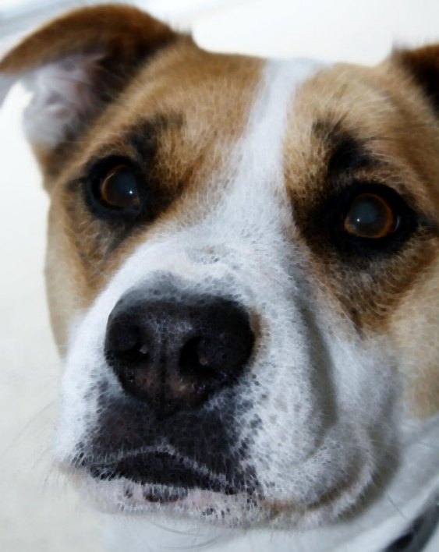
Result
Thus, the image was successfully eroded using OpenCV.

